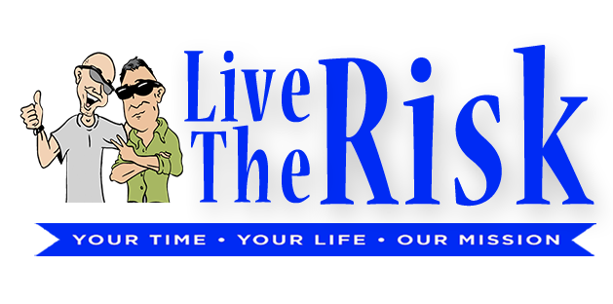
Go For Your Dream
Checklist

Checklist
F

- Do you have a dream?
If yes, is your dream powerful, personal, and specific? If no, why not? What is holding you back from setting your ultimate direction?

- Have your achieved your dream? Are you living it today?
If so, admire every view along the way; remember, if you are living outside your comfort zone - your path is new. Enjoy the journey. If no, are you aware of the obstacles in your way?

- Have you made preparations to have the ride of your life?
If yes, do you know where you are going and what you need to get there in order to be successful? Are you preparing yourself for your success? (Remember, you have to do the work to get what you want.) If no, do you know what you need to do to make your dream a reality?

- Have you established your wingman (friend, family, etc.) to provide moral support while you achieve your dream?
If yes, how will they need to support you while you obtain your dream? If no, why not? You don't have to walk your path alone. A wingman will help you to see the journey from a different perspective.

- Can you maintain your motivation, focus, and commitment to obtain your dream?
If yes, perfect. What can you do to intensify your attitude and awareness to obtain your dream? If no, you said you wanted to do this. So why aren’t you motivated, focused, and committed to doing it? Do it! Don’t give up.

- Do you have a clear understanding of the pitfalls and obstacles to obtain your dream?
If yes, are you taking the appropriate measures to avoid your pitfalls and obstacles? If no, why not? Your success astronomically improves when you review the obstacles and already have a contingency plan to avoid them. Take measured steps, and if you do fall down, pick yourself up and keep going.

- Have you taken actions TODAY that support your dream?
If yes, can you keep up the momentum? What will be your next action? When will it be done? Have you established all your future goals as magnetic? If no, are you taking a break or are you avoiding actions on your dream? It is okay to take a break when you need to rest. It is not okay to avoid things that you promised yourself.

- Do you have a Roadmap to obtain your dream?
If yes, AWESOME! You are on your way! If no, why not? Why are you waiting? What is in your way from obtaining what you want? Keep your goal in view, even when you can't see it. If it's not, your mind will create the reasons why you don't need to accomplish it today.

LiveTheRisk.com

